August 20, 2015

Dr. Michael Meyer
Mars Exploration Program Lead Scientist
Planetary Science Division
Science Mission Directorate
NASA Headquarters
300 E Street SW
Washington, DC 20546
Dear Michael:
The purpose of this letter is to summarize the outcome of the joint Mars 2020 Project, Mars 2020 Project Science Group, Mars Exploration Program, and Mars 2020 Landing Site Steering Committee meeting held in Monrovia, CA, on the afternoon of August 6, 2015. This meeting was held immediately following the 2nd Mars 2020 Landing Site Workshop, also held in Monrovia, CA, on August 4-6, 2015.
The purpose of the post-landing site workshop joint meeting was to discuss the Mars 2020 landing site inputs from the science community and select eight sites for further engineering and science evaluation ahead of the next planned landing site workshop, scheduled for January 2017. The eight sites selected are (in alphabetical order):
- Columbia Hills/Gusev
- Eberswalde
- Holden
- Jezero
- Mawrth
- NE Syrtis
- Nili Fossae
- SW Melas
These sites are also shown on the map in Figure 1.
Of the eight sites selected for further investigation, there is only one difference versus the landing site rankings based on scientific criteria produced at the landing site workshop: the Nili Carbonate site was not selected. Instead, the 9th ranked site from the landing site workshop was selected.
Nili Carbonate was not selected for further work due to a high risk engineering assessment and scientific overlap with other selected sites. The engineering viability of the Nili Carbonate site depends on a significant reduction in landing ellipse margin that may not be realizable. Removing the site allows conservation of limited project resources for sites that are more likely to be acceptable from a landing safety perspective. Additionally, the carbonate science and geological context are available at other sites selected for further investigation.
Preliminary engineering analyses show that Terrain Relative Navigation (TRN) is required to guarantee access to most of the top eight sites. Only one appears to be a guaranteed non-TRN site (Nili Fossae), while two others may or not may be accessible safely without TRN (Columbia Hills, Holden). Half of the top-ranked landing sites are deltaic environments (Eberswalde, Holden, Jezero, SW Melas) reflecting the strong belief in the science community that rocks in deltas are amongst the most favorable for recording signatures of possible ancient life; landing at any of these sites is expected to require TRN.
Please let us know if you have any questions related to the outcome of the joint meeting. We look forward to further developing the engineering and science cases for the selected landing sites as we prepare for the third landing site workshop in 2017.

Sincerely,

Ken Farley
Mars 2020 Project Scientist

Ken Williford
Mars 2020 Deputy Project Scientist

John Grant
Co-Chair, Mars 2020 Landing Site Steering Committee

Matt Golombek
Co-Chair, Mars 2020 Landing Site Steering Committee

Allen Chen
Mars 2020 Landing Site Selection Coordinator

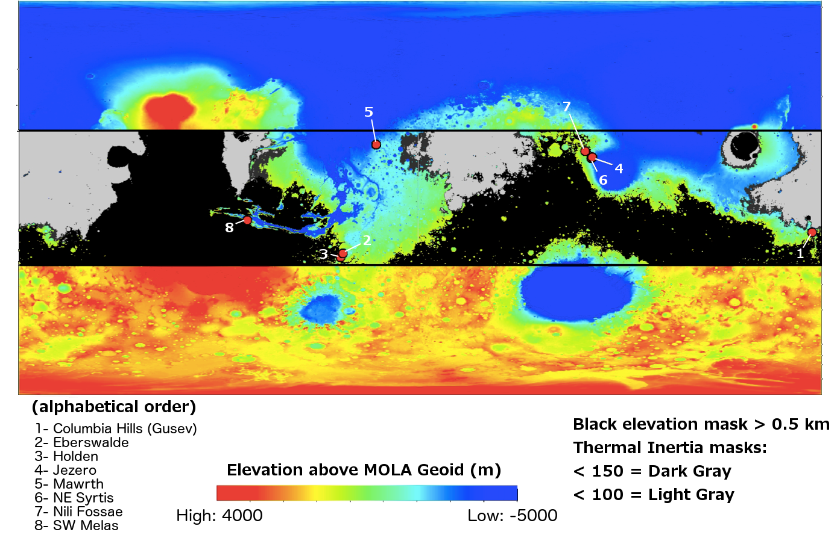
Figure 1. Landing Sites Selected for Further Investigation

