TEMPLATE FOR ACQUIRING IMAGES OF PROSPECTIVE LANDING SITES FOR THE 2020 MARS MISSION
P. Investigator and Affiliation.

Introduction: Provide a short summary of the science and engineering merit of the candidate site along with any supporting references that can be provided. Give detailed location information (latitude, longitude of center of proposed landing ellipse) and the location of the target material. Include a figure with the proposed ellipse (see below) and the areas of prime science interest, their priority and location in or out of the ellipse. Include footprints of images that can be acquired by instruments on orbiting spacecraft that will help the investigation. Describe the investigation proposed and how that will better define the science that can be addressed at the landing site by the 2020 mission and its importance. The abstract does not need to exceed 3 pages and can be submitted through November 15, 2013.
Science Merit Related to Mission Objectives: The Mars 2020 mission would explore a site likely to have been habitable, seek signs of past life, fill a returnable cache with the most compelling samples, take the first steps towards in situ resource utilization on Mars, and demonstrate technology needed for the future human and robotic exploration of Mars. A more detailed description of the proposed mission objectives can be found in the Mars 2020 SDT report [Mustard et al., 2013]. The science requirements for caching are the most demanding and will likely govern the landing site selection process.
A description of how the proposed landing site potentially satisfies the likely science objectives of the candidate mission should be provided. Comments could include discussion (as is possible) of the targeted materials or context (e.g., multiple rock units present or expected of diverse morphology and mineralogy that display systematic trends and clear stratigraphy and cross-cutting relations). Context could include the expected geologic framework and chronology of the site and whether it will likely enable placement of surface observations into regional context (geologic context). Any mineralogical, volatile, or geomorphic evidence important for the interpretation should be included. Information supporting the key interpretations of the site should be included.
Science Criteria: Science criteria on potential 2020 landing sites are based on the findings of the Mars 2020 SDT [Mustard et al., 2013]. All potential landing sites must met the threshold geological criteria to be retained for further consideration. The potential qualifying geological criteria will be used to rank sites that meet the threshold criteria.
Threshold Geological Criteria:
- Presence of subaqueous sediments or hydrothermal sediments (equal 1st priority),
OR
hydrothermally altered rocks or Low-T fluid-altered rocks (equal 2nd priority)
- Presence of aqueous phases (e.g., phyllosilicates, carbonates, sulfates, etc.) in outcrop
- Noachian/Early Hesperian age based on stratigraphic relations and/or crater counts
- Presence of igneous rocks with known stratigraphic relations, of any age, to be
identified by primary minerals.
- Not a Special Region
Potential Qualifying Geological Criteria:
- Morphological criteria for standing bodies of water and/or fluvial activity (deltaic deposits, shorelines, etc.).
- Assemblages of secondary minerals of any age.
- Presence of former water ice, glacial activity or its deposits.
- Igneous rocks of Noachian age corresponding to unaltered primitive crust, better if including exhumed megabreccia.
- Volcanic unit of Hesperian or Amazonian age well-defined by crater counts and well-identified by morphology and/or mineralogy.
- Probability of samples of opportunity (ejecta breccia, mantle xenoliths, etc.).
- Potential for resources for future human mission
Engineering Constraints: Engineering constraints on potential 2020 landing sites are based on those derived for the MSL “sky crane” landing system [Golombek et al., 2012], with some important exceptions.
Elevation: Below +0.5 km MOLA elevation, with respect to the MOLA geoid.
Latitude: Within 30° of the equator.
Landing Ellipse: Like MSL, the 2020 mission has a nominal landing ellipse of about 25 km by 20 km, oriented roughly east-west. A potential improvement under investigation, called range trigger, would allow landing within a 18 km long by 14 km wide ellipse. It may be possible in the future that the range trigger ellipse could become as small as 13 km by 7 km.
Terrain Relief and Slopes:
Less than ~100 m of relief at baseline lengths of 1-1,000 m to ensure proper control authority and fuel consumption during powered descent.
Less than 25°-30° slopes at length scales of 2-5 m to ensure stability and trafficability of the rover during and after landing.
Rocks: The probability that a rock taller than 0.55 m high occurs in a random sampled area of 4 m² (the area of the belly pan and area out to the inside of the wheels) should be less than 0.5% for the proposed sites. This corresponds broadly to 7% rock abundance, which is near the mode in the rock abundance for Mars as estimated from thermal differencing techniques. Subsequent analysis indicates the most critical area is just the belly pan of the rover, which covers ~2.7 m² and can tolerate 0.6 m high rocks, which corresponds to about 12% rock abundance. Because rocks will eventually be counted in HiRISE images, rock abundance could locally be up to 20% provided that the overall risk for the ellipse does not exceed the 0.5% probability level.
Radar Reflectivity: The Ka band radar backscatter cross-section must be > -20 dB and < +15 dB at Ka band to ensure proper measurement of altitude and velocity by the radar velocimeter/altimeter of the descent vehicle.
Load Bearing Surface: Surfaces with thermal inertias greater than 100 J m⁻² s^{-0.5} K⁻¹ and albedo lower than 0.25 and radar reflectivities >0.01 to avoid surfaces dominated by dust that may have extremely low bulk density and may not be load bearing. Surfaces with thermal inertias less than ~150 J m⁻² s^{-0.5} K⁻¹ with high albedo may also be dusty and so should flagged for further investigation.
Enhanced EDL Capabilities-Hazard Tolerance: Under investigation is the possible inclusion of enhancements to MSL EDL capabilities and the possible inclusion of Terrain Relative Navigation technology that would allow the consideration of landing sites with some areas that exceed the relief and rock constraints. A conceptual Terrain Relative Navigation system would allow areas of <150 m radius that violate the slope and rock constraints within the ellipse so long as they are surrounded by areas >100 m radius that appear safe for the landing system (i.e., that meet the engineering constraints).
These constraints are preliminary and subject to change. In some cases they could be broader than what the eventual spacecraft can accommodate; the intent is to be biased toward identifying all scientifically interesting landing sites. It is possible that these capabilities may not ultimately be fully or partially implemented, rendering some initial sites non-viable in the future.
Planetary Protection: Mars 2020 has not received a Planetary Protection categorization yet. However, the Mars 2020 SDT report concluded that the primary mission objective of exploring an ancient environment does not require the mission to access Special Regions. Special Regions are defined as areas where water or water-ice is suspected to be present within ~1 meter of the surface. Because of this conclusion and the fact that the high MSL heritage in the engineering systems do not readily support the Category IVc classification that would accompany a mission that landed in a Special Region, it is assumed that these regions will not be landing site targets. Additional information on this topic can be found in the Mars 2020 SDT Report, Section 8.4 [Mustard et al., 2013].
Information Required for Potential New Landing Sites: In order to review, evaluate, and obtain information on potential new landing sites, certain standard information will be needed.
Landing Ellipse: A visual image or map showing the landing site is required. Figure 1 shows an example of a High Resolution Stereo Camera (HRSC) image. The image background could be any easily obtainable image such as MOLA shaded relief, THEMIS thermal, HRSC, CTX or other image base. The ellipse must be shown on the map, with the ellipse size and the center latitude and longitude provided (preferably in MOLA planetocentric coordinates). Areas of science interest in and around the ellipse should also be designated on the image. Also a table (Table 1) that includes the name of the site, the ellipse center coordinates, site elevation, ellipse size, the prime science and/or sampling targets, and the distance and priority of the prime science targets from the center of the ellipse.
The location of any existing high-resolution data (e.g., MOC; MRO HiRISE, CTX and CRISM) in or near the ellipse should also be indicated (Figure 1). For additional images being requested, their location should also be shown in priority order, with due consideration given to typical image sizes. In general, the surface of any proposed landing site must appear smooth and flat throughout the ellipse in available images and topographic maps. While we do not expect detailed analysis of potential hazards in the ellipse by site proposers, we would like to be made aware of any potential hazards known to be present. We are interested in knowing if the landing site requires enhanced EDL capabilities, like TRN and if the landing site location might change with TRN (e.g., from “go to” to “land on” site).
Table 1: Example table required for any landing site proposed.
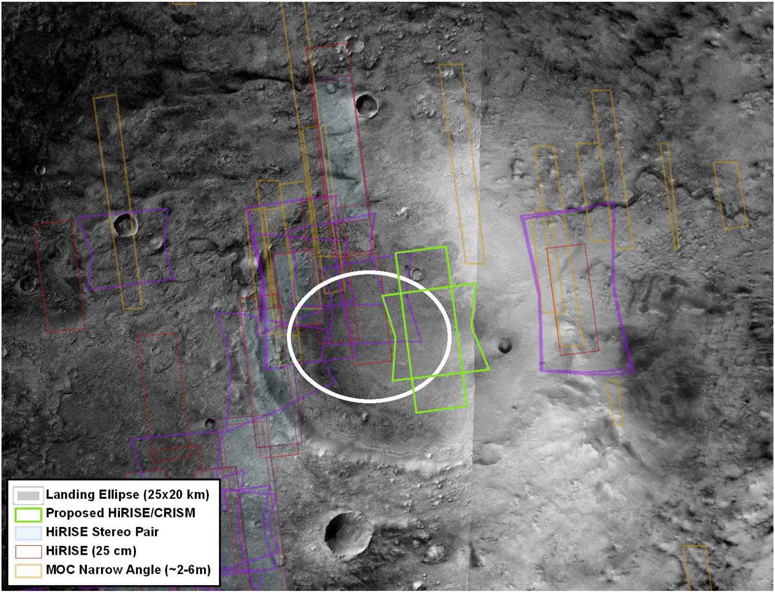
Figure 1: Example 25 km by 20 km ellipse on HRSC image at Jezero crater. The ellipse is centered at 18.36°N, 77.59°E at an elevation of -2.66 km with respect to the geoid in MOLA planetocentric coordinates. The prime science targets are phyllosilicates within a delta just to the northwest of the ellipse. The footprints of existing HiRISE, CRISM (in purple), and MOC images are shown. In green are the requested HiRISE image (rectangle) and CRISM image (hourglass shape) centered at 18.365°N, 77.719°E.
Site Name | Ares
Center Coordinates  Latitude, longitude | XX°N or XX°S, YY°E
Elevation | XX.X km wrt MOLA
Prime Science and/or Sampling Targets | e.g., Smectites [Highest Priority],  Layered materials,  Channels [Lowest Priority]
Distance of Science and/or Sampling Targets from Ellipse Center | Smectites – 13 km to W  Layers – 8 km to NW  Channels – 3 km to E
Rationale for Images: Describe in enough detail how the proposed images would improve the definition of the science that could be addressed at the landing site. Describe how the images to be acquired would improve the understanding of the geologic setting, history and environment of the landing site. Explain the science rationale for the landing site and how materials available at the landing site can address the science objectives of the 2020 mission. Imaging requests would be evaluated on how the new information would better define the science that could be accomplished at the landing site.
References: Please provide references in standard journal format with full title and citation. References do not count towards the 3 page limit for the abstract.
Golombek, M., et al., 2012, Selection of the Mars Science Laboratory landing site, Space Science Reviews, 170, 641-737, DOI: 10.1007/s11214-012-9916-y.
Mustard, J.F. (chair), M. Adler, A. Allwood, D.S. Bass, D.W. Beaty, J.F. Bell III, W.B. Brinckerhoff, M. Carr, D.J. Des Marais, B. Drake, K.S. Edgett, J. Eigenbrode, L.T. Elkins-Tanton, J.A. Grant, S.M. Milkovich, D. Ming, C. Moore, S. Murchie, T.C. Onstott, S.W. Ruff, M.A. Sephton, A. Steele, A. Treiman, 2013, Report of the Mars 2020 Science Definition Team, 154 pp., posted July 2013 by the Mars Exploration Program Analysis Group (MEPAG) at http://mepag.jpl.nasa.gov/reports/MEP/Mars_2020_SDT_Report_Final.pdf

